Final project notes:

It’s My Raye Raye App   
(Create as a native app – not as embedded web contents displayed in Web View)

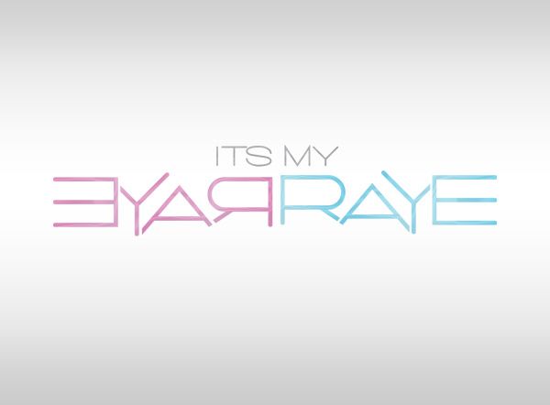

Social Media Presence

1. Instagram.com/itsmyrayeraye
2. itsmyrayeraye.tumblr.com/
3. <https://twitter.com/itsmyrayeraye>
4. <https://www.facebook.com/ItsMyRayeRaye>
5. <https://www.pinterest.com/mariahchaday/itsmyrayeraye/>
6. https://www.youtube.com/user/ItsMyRayeRaye
7. App on iTunes
   1. It’s My Raye Raye

API’s

<https://developers.google.com/youtube/>

<https://developers.facebook.com>

<https://instagram.com/developer/>

<https://dev.twitter.com/rest/public>

<https://www.tumblr.com/docs/en/api/v2>

<https://developers.pinterest.com>

App Features

1. YouTube Feed – users can watch all videos from the YT Feed
   1. What type of interface does YT allows me access
2. Product List – users can view a list of recommended products featured in videos
   1. Product name
   2. Product cost
   3. Where to buy
3. Users can share video content on FB, Twitter, Pinterest, Instagram, etc
4. Events/Appearances
   1. Info/details
   2. RSVP
   3. Map
   4. Share on FB/Twitter
5. News
   1. https://www.youtube.com/user/Pantene?v=Ug3Tc4IKJOM
6. Push Notifications – this will be an external website that will notify users of any news related to Raye Boyce or her brand. Example: Her Pantene commercial aired during the
   1. Alert users a new YT video has been posted
   2. https://www.youtube.com/user/Pantene?v=Ug3Tc4IKJOM

Color Scheme

Pink (227, 166, 200)

Blue (116, 200, 224)

Grey (169, 169, 171)

Color Palette (http://paletton.com)

<http://paletton.com/#uid=15y050kaRoXc7CEa1uFaekQ8ggw>

base color: BD7D86



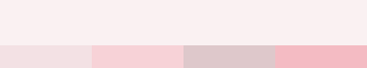



Timeline

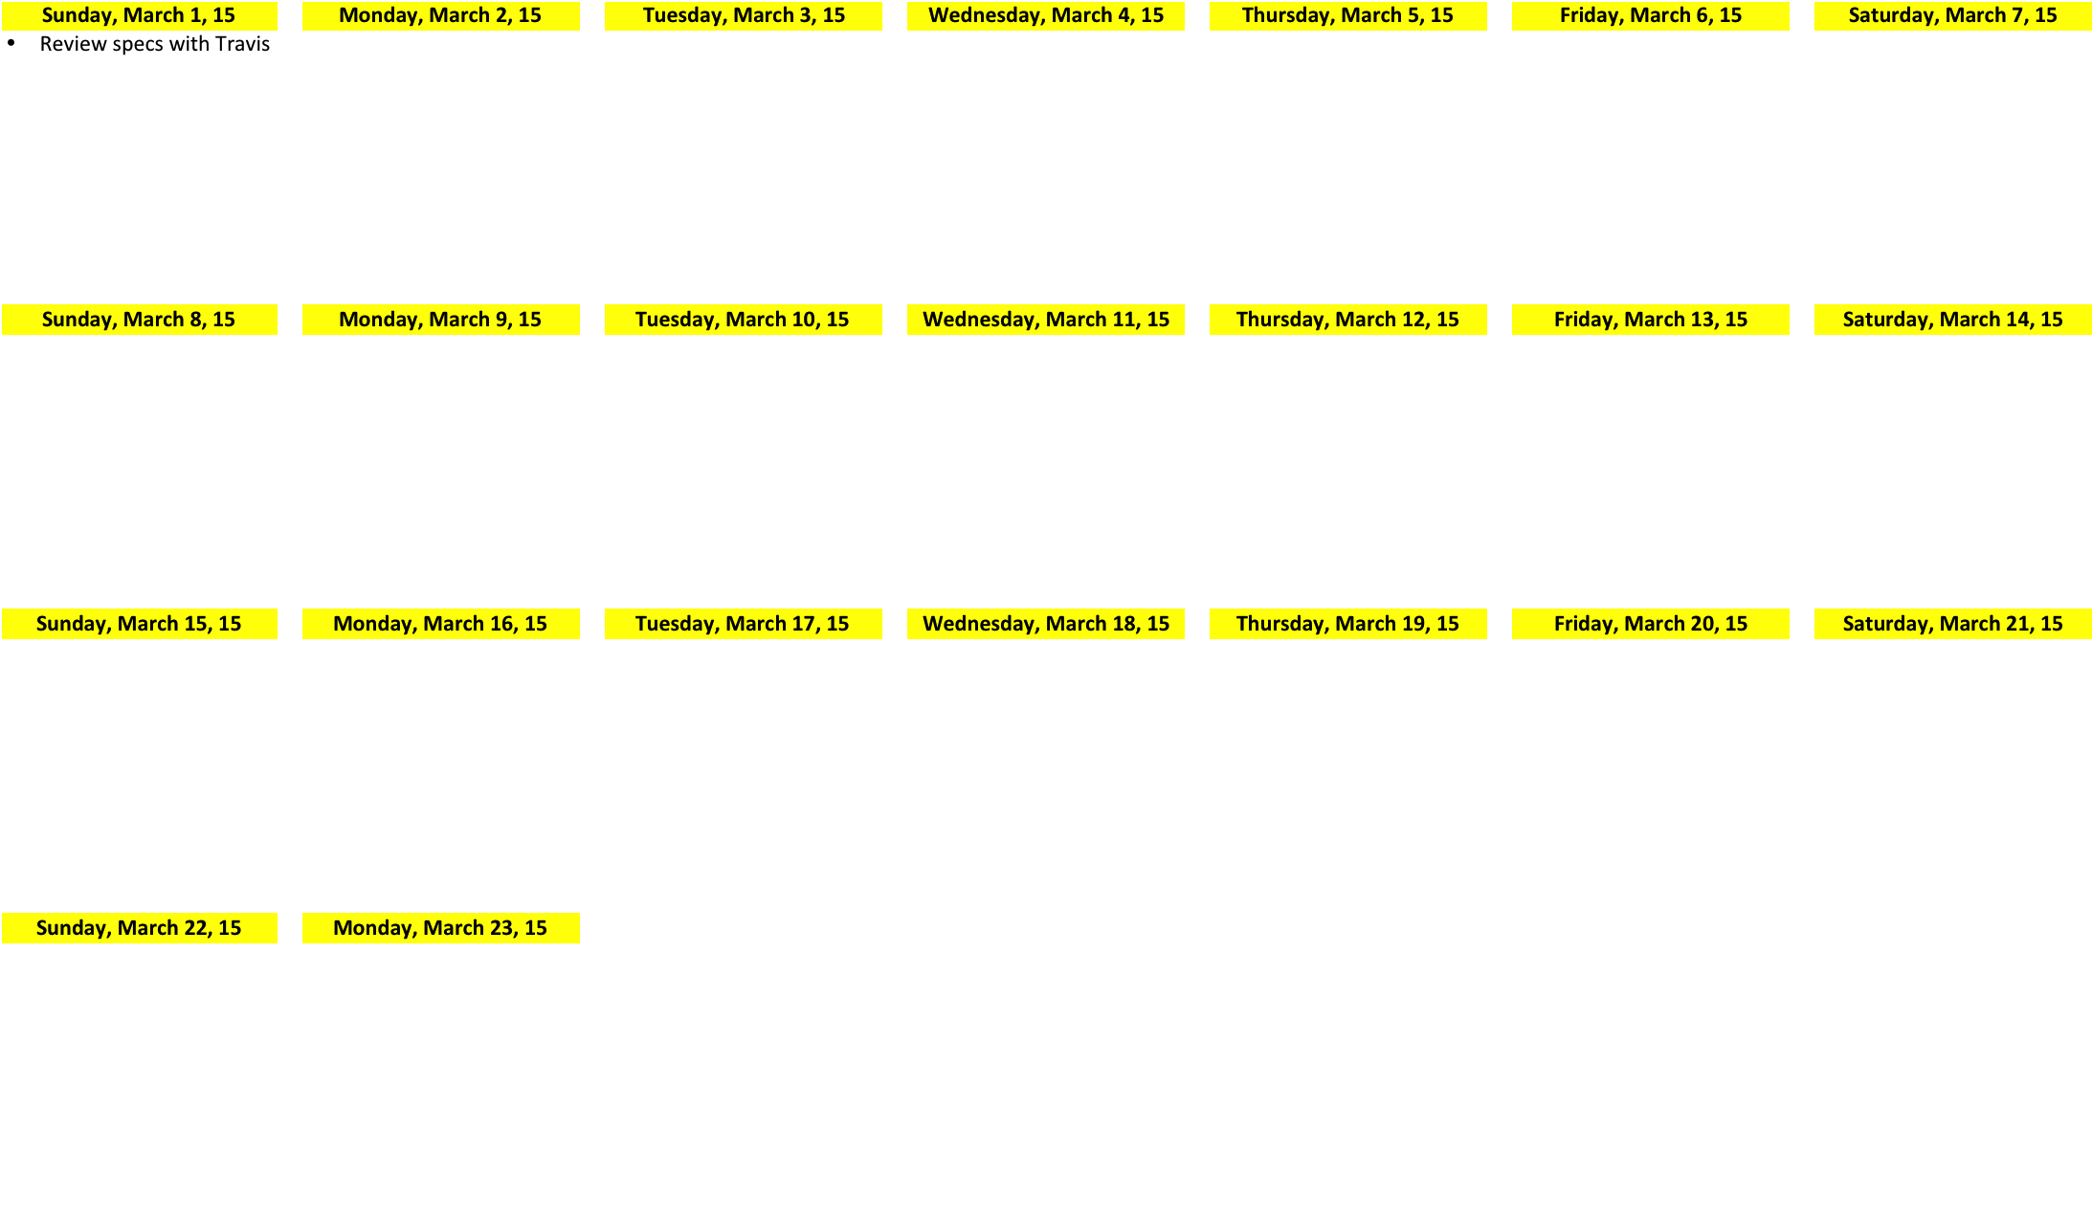

Getting started:

1. Recreate existing app on iTunes in an Xcode project.

Resources:

Adding a YTPlayerView via Interface Builder or the Storyboard

https://developers.google.com/youtube/v3/guides/ios_youtube_helper#adding_ytplayerview